**Transmission in Vehicle**

Name: Shubham Sunil Patil

Emp ID: 214860

Mail ID: [shubhamp7@kpit.com](mailto:shubhamp7@kpit.com)

Location: Pune

**Definition of Transmission System: -**

The mechanism that transmits the power developed by the engine of automobile to the engine to the driving wheels is called the TRANSMISSION SYSTEM (or POWER TRAIN).

**It is composed of –**

* **Clutch**
* **The gear boxes**
* **Propeller shaft**
* **Universal joints**
* **Rear axle**
* **Wheel**
* **Tyres**

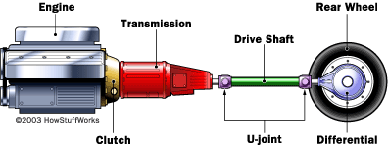

**Requirements of Transmission System: -**

Provide means of connection and disconnection of engine with rest of power train without shock and smoothly. Provide a varied leverage between the engine and the drive wheels. Provide means to transfer power in opposite direction. Enable power transmission at varied angles and varied lengths. Enable speed reduction between engine and the drive wheels in the ratio of 5:1. Enable diversion of power flow at right angles. Provide means to drive the driving wheels at different speeds when required. Bear the effect of torque reaction, driving thrust and braking effort effectively.

**The above requirements are fulfilled by the following main units of transmission system: -**

* **Clutch**
* **Gear Box**
* **Transfer Case**
* **Propeller Shaft and Universal Joints**
* **Final Drive**
* **Differential**
* **Torque Tube**
* **Road Wheel**
* **Clutch: -**

A clutch is a mechanism which enables the rotary motion of one shaft to be transmitted at will to second shaft, whose axis is coincident with that of first. Clutch is located between engine and gear box. When the clutch is engaged, the power flows from the engine to the rear wheels through the transmission system and the vehicle moves. When the clutch is disengaged, the power is not transmitted to the rear wheels and the vehicle stops, while the engine is still running.

Clutch is disengaged when-

a) Starting the engine,

b) Shifting the gears,

c) Idling the engine

* Clutch is engaged only when the vehicle is to move and is kept engaged when the vehicle is moving.
* **Gear Box: -**

A box containing gears. In the most basic sense, a gearbox functions like any system of gears; it alters torque and speed between a driving device like a motor and a load. The gears inside of a gearbox can be any one of a number of types from bevel gears and spiral bevel gears to worm gears and others such as planetary gears. The gears are mounted on shafts, which are supported by and rotate via rolling element bearings. The gearbox is a mechanical method of transferring energy from one device to another and is used to increase torque while reducing speed.

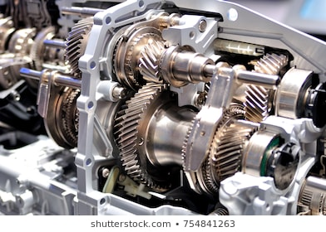

**Gear box in Simulation: -**

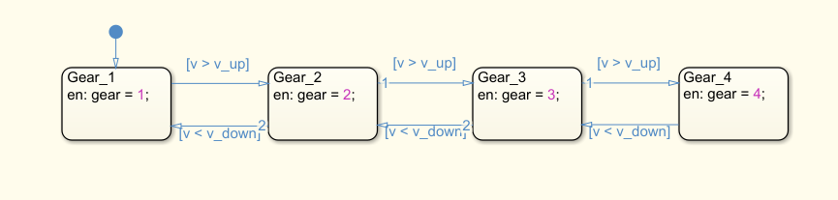

* **Engine: -**

An engine or motor is a [machine](https://en.wikipedia.org/wiki/Machine) designed to convert one form of [energy](https://en.wikipedia.org/wiki/Energy) into [mechanical energy](https://en.wikipedia.org/wiki/Motion_(physics)). [Heat engines](https://en.wikipedia.org/wiki/Heat_engine) convert [heat](https://en.wikipedia.org/wiki/Heat) into work via various thermodynamic processes. The [internal combustion engine](https://en.wikipedia.org/wiki/Internal_combustion_engine) is perhaps the most common example of a heat engine, in which heat from the [combustion](https://en.wikipedia.org/wiki/Combustion) of a [fuel](https://en.wikipedia.org/wiki/Fuel) causes rapid pressurisation of the gaseous combustion products in the combustion chamber, causing them to expand and drive a [piston](https://en.wikipedia.org/wiki/Piston), which turns a [crankshaft](https://en.wikipedia.org/wiki/Crankshaft). [Electric motors](https://en.wikipedia.org/wiki/Electric_motor) convert electrical energy into [mechanical](https://en.wikipedia.org/wiki/Machine_(mechanical)) motion, [pneumatic motors](https://en.wikipedia.org/wiki/Pneumatic_motor) use [compressed air](https://en.wikipedia.org/wiki/Compressed_air), and [clockwork motors](https://en.wikipedia.org/wiki/Clockwork_motor) in [wind-up toys](https://en.wikipedia.org/wiki/Wind-up_toy) use [elastic energy](https://en.wikipedia.org/wiki/Elastic_energy). In biological systems, [molecular motors](https://en.wikipedia.org/wiki/Molecular_motor), like [myosin’s](https://en.wikipedia.org/wiki/Myosin) in [muscles](https://en.wikipedia.org/wiki/Muscle), use [chemical energy](https://en.wikipedia.org/wiki/Chemical_energy) to create forces and ultimately motion.

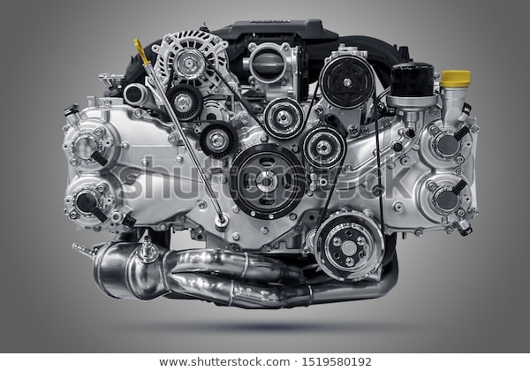

**Engine in Simulation: -**

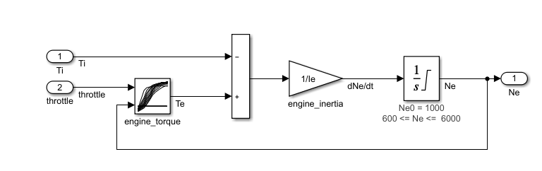

* **Torque converter: -**

A torque converter is a type of [fluid coupling](https://en.wikipedia.org/wiki/Fluid_coupling) which transfers rotating power from a [prime mover](https://en.wikipedia.org/wiki/Prime_mover_(locomotive)), like an [internal combustion engine](https://en.wikipedia.org/wiki/Internal_combustion_engine), to a rotating driven load. In a vehicle with an [automatic transmission](https://en.wikipedia.org/wiki/Automatic_transmission), the torque converter connects the power source to the load. It is usually located between the engine's [flex plate](https://en.wikipedia.org/wiki/Flexplate) and the transmission. The equivalent location in a manual transmission would be the mechanical [clutch](https://en.wikipedia.org/wiki/Clutch). The main characteristic of a torque converter is its ability to increase [torque](https://en.wikipedia.org/wiki/Torque) when the output rotational speed is so low that it allows the fluid coming off the curved vanes of the turbine to be deflected off the stator while it is locked against its one-way clutch, thus providing the equivalent of a [reduction gear](https://en.wikipedia.org/wiki/Transmission_(mechanics)). This is a feature beyond that of the simple fluid coupling, which can match rotational speed but does not multiply torque, thus reduces power.

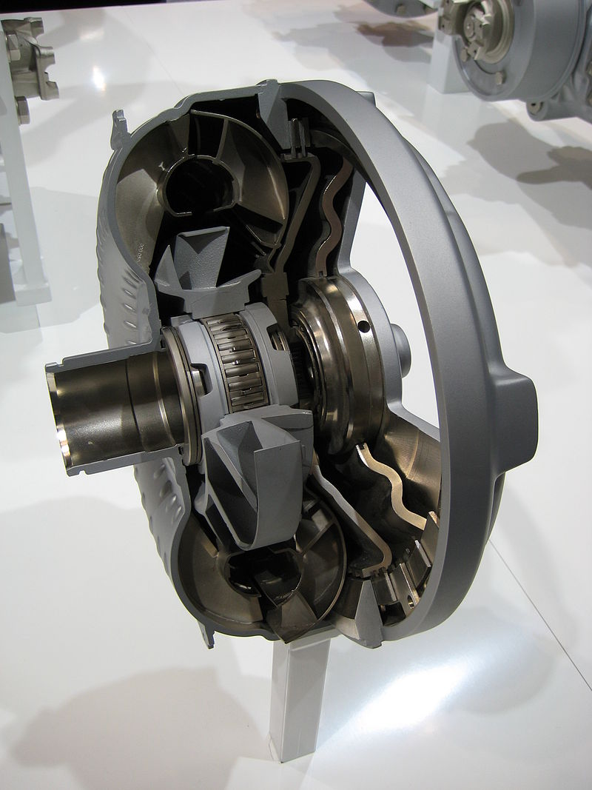

**Torque converter in simulation: -**

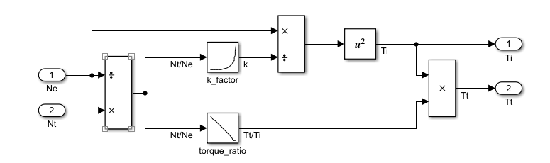

**Simulation of Transmission in Vehicle: -**

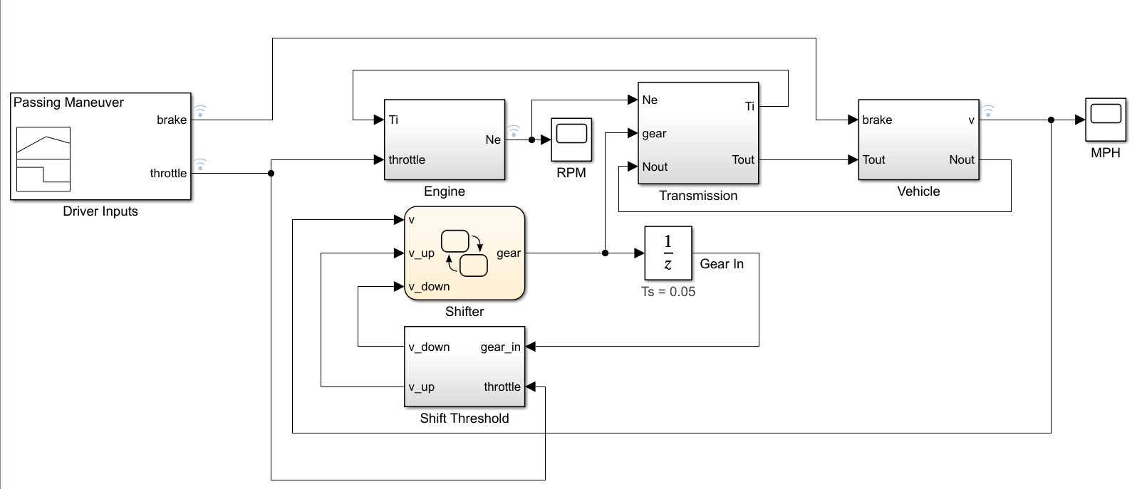

**Uses of call-backs: -**

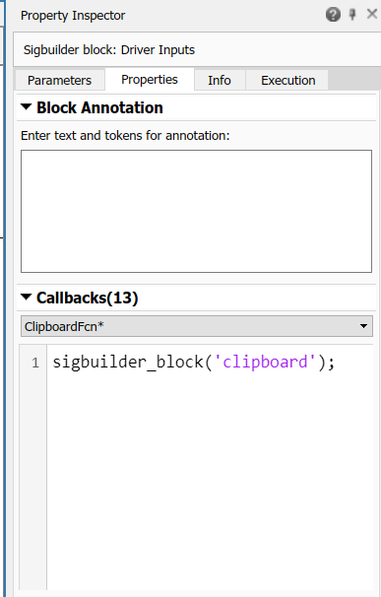

**Uses of Data Inspector: -**

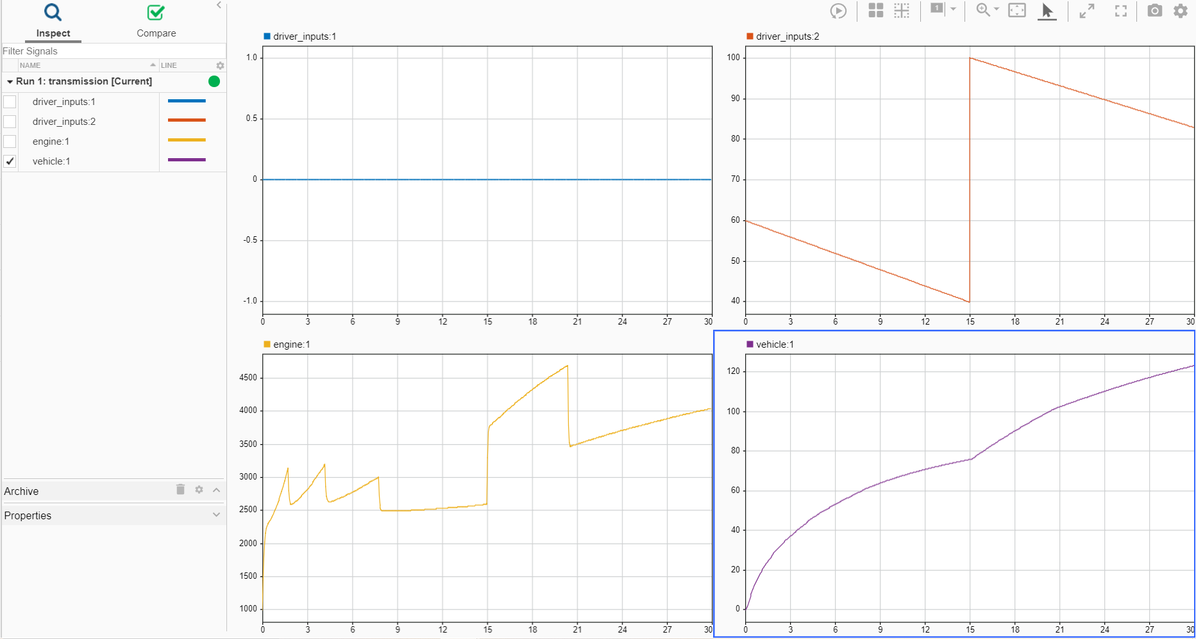

**Uses of Look-up table: -**

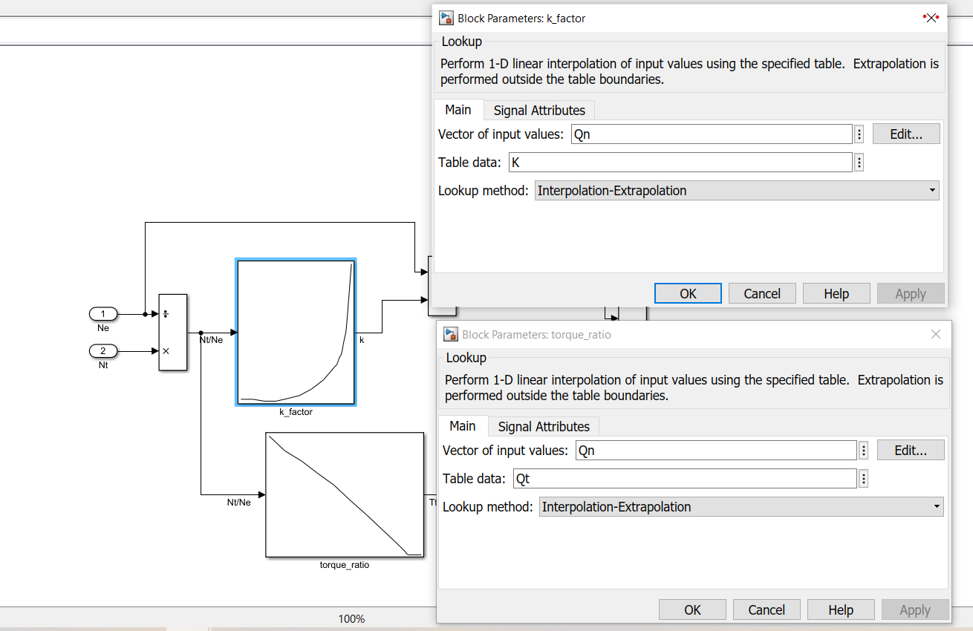

**Uses of Solver selection strategy: -**

